20BCE1214 Aryaan Chauhan IWP LAB-9

1)

Code

<?php

$handle=fopen('employee.txt','w');

fwrite($handle,"ID-Name-Qualification-Designation\n");

echo "write ID, name Qualification and designation of 5 employees\n";

for($i=0;$i<5;$i++)

{

$s="";

$id=readline();

$na=readline();

$qa=readline();

$de=readline();

$s=$s.$id." - ".$na." - ".$qa." - ".$de;

fwrite($handle,$s.PHP_EOL);

}

copy('employee.txt','copyofemployee.txt');

rename('copyofemployee.txt','copy_1.txt');

fclose($handle);

?>

Output: Consisting of command prompt, file employee.txt and copyofemployee.txt renamed to copy_1.txt

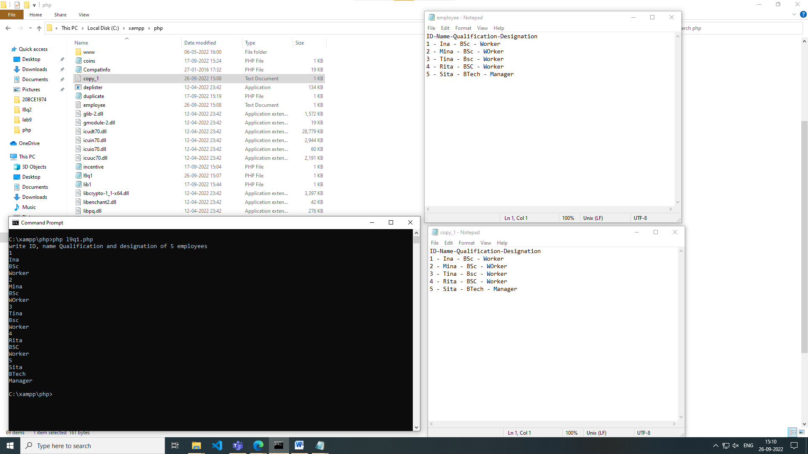

2)

Code:

Html file:

<html>

<head>

<title>Q2</title>

</head>

<body>

<form method="post", action="l9q2p.php">

<input type="text" name="data1"><br>

<input type="number" name="data2"><br>

<input type="number" name="data3"><br>

<input type="number" name="data4"><br>

<input type="submit" name="submit">

</form>

</body>

</html>

.php file

Code:

<?php

if(isset($_POST['submit']))

{

$a=$_POST['data1'];

$b=$_POST['data2'];

$i=$_POST['data3'];

$c=$_POST['data4'];

$d1=$i*(0.3);

$d2=$c*(0.2);

$d3=sqrt($b);

$e=$d1+$d2-$d3;

echo "Extra bonus points =".$e;

$handle=fopen('data.txt','w');

fwrite($handle,$e);

fclose($handle);

}

?>

Output:



